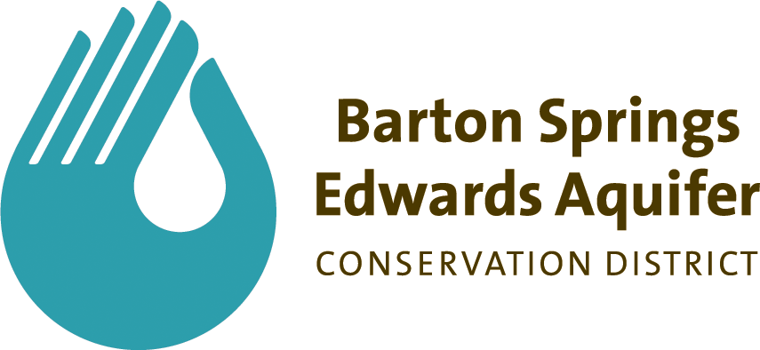

# For Immediate Release: Tuesday, April 29, 2014

For more information, contact: Alan Andrews at (512) 282-8441 or aandrews@bseacd.org

**Aquifer District Announces Winners of 2014 Scholarship Contests**

(Austin) - The Barton Springs/Edwards Aquifer Conservation District has announced the winners of the Kent S. Butler Memorial Groundwater Stewardship College Scholarship Essay Contest and its Aquatic Science Adventure Camp Scholarship program.

The District would like to thank Creedmoor-Maha WSC, Texas Lehigh Cement Company, St. Andrews Episcopal School, and Goforth Water SUD for donating a portion of their Conservation Credits to the scholarship program.

**Kent S. Butler Memorial Groundwater Stewardship College Scholarship**

The District's college scholarship is dedicated as a memorial scholarship honoring one of Austin's most influential environmental planners, Dr. Kent S. Butler. Dr. Butler specialized in bringing science and policy together. He encouraged open conversation, collaboration, and participation from all perspectives. The Kent S. Butler Groundwater Stewardship Scholarship Essay Contest increases the awareness of groundwater issues by rewarding high school students for high quality research and writing.

This year’s winner of the essay contest is Bowie High School junior Jenna Trejo. An independent evaluation panel scored Ms. Trejo’s essay, titled “Kubla Khan: Protecting Our Groundwater One Drop at a Time,” with the highest marks for content, accuracy of information, originality, grammar, quality of research, and style. She will receive a $2,500 scholarship to the college, community college, or training institution of her choice. Essays had to focus generally on groundwater or groundwater issues; however, it was not mandatory that applicants be planning a career in water resources. High School students attending public schools in the Austin, Eanes, Dripping Springs, Hays Consolidated, Del Valle, Bastrop, and Lockhart Independent School Districts, as well as private and home-schooled students in these areas, were eligible.

District staff selected at-large judges from the Austin area along with a District staff member to read and evaluate the essays. This year’s judges were Christy Muse, Executive Director of the Hill Country Alliance; Louise Liller, Volunteer Coordinator with the City of Austin; Doug Wierman, Environmental Consultant with ERM; Dave Anderson, Consultant with FORM; Stacey Steinbach, Executive Director of the Texas Alliance of Groundwater Districts; Jennifer Walker, Water Resources Coordinator with the Sierra Club; and Vanessa Escobar, BSEACD Regulatory Compliance Coordinator.

**Aquatic Science Adventure Camp Scholarships**

The District awards program also includes additional age groups of District-area students through scholarships to the Edwards Aquifer Data and Research Center’s Aquatic Science Adventure Camp at Texas State University in San Marcos. This very successful program required interested students to submit an application and a 1-page essay/artwork entitled "Why I want to attend the Aquatic Science Adventure Camp!" to establish eligibility. The contest was open to children ages 9 through 15 who reside in one of the six school districts that cross the District's boundary.

Four winners for 5-day camp scholarships and five winners for 2-day camp scholarships were chosen in a random drawing. 2014 Winners of the 5-day camp scholarship are Somaya Jimenez-Haham of Austin Discovery School and Skylar Koenig, Katelyn Alren, and Savannah Kelsey of Pfluger Elementary School. 2014 Winners of the 2-day camp scholarship are Griffin Rans of Mills Elementary, Kaitlyn Manire of Gorzycki Middle School, and Megan Morris, Sarai Diaz, and McKenzi Pritchard of Pfluger Elementary.

All winners are invited to be special guests of the District’s Board of Directors at its regular meeting at 6:00pm on Thursday, May 8th, to be officially acknowledged and commended for their efforts. The meeting will be held a District Headquarters at 1124 Regal Row, Austin, 78748. Public and media are welcome.

For information about future scholarship programs visit www.bseacd.org.

*BSEACD is a groundwater conservation district charged by the Texas Legislature to preserve, conserve, and protect the aquifers and groundwater resources within its jurisdiction, which includes parts of three Central Texas counties. It is governed by a Board of five elected directors and staffed with hydrogeologists, groundwater regulatory compliance specialists, environmental educators, geospatial systems specialists, and administrative support personnel.*

*#*